Epsom & Ewell F.C.
8
v
Knaphill
Tuesday, 14th October 2014
For our League Cup Second Round tie this evening we welcome the players, officials and supporters of Knaphill F.C., along with today's match officials and of course our own regular supporters.

Today’s visitors had the worst possible start to life in the Premier Division when opening the season with an 0-6 home defeat to Camberley Town, but since then, they have begun to find their feet and although we won fairly comfortably over there in October, I feel that our opponents will provide us with a sterner test tonight.

This is our opponents first visit to our temporary home at High Road having met twice before at Redding Way; the first of which was also in this competition when a couple of Dave Francis goals added to a Nathan Ayling mishit gave us a 3-2 win in a First Round tie just over three years ago.

We met Bedfont Sports on Saturday and I think we were unfortunate to lose the game as a result of the only goal, decent move though it was. Many chances went begging and this was frustrating because you felt that if we had got one we would have gone on to get a hatful. We will do this to a team shortly, I am sure.

We are at home once again on Saturday as Ashford Town make their first visit to us since 2003 for a League match. We then face another tough game when travelling to Camberley Town before returning here on the Tuesday when we host Chertsey Town.

Further ahead we have a fixture change as our home match with Spelthorne Sports has been moved back due to a Chipstead rearrangement. The new date will be announced in around a week so please keep checking the website.

Please note that we are still looking for player, match and match ball sponsors. Please take a look at the relevant section within the programme and please help your club; even if a couple of you pool together it all helps us and we are very grateful.

Finally, I must advise that this game could go to extra time and even penalties if the scores remain level, hence the slightly earlier kick off time today.

Enjoy the game!

Rich (Richard.c.lambert@gmail.com) on Twitter @EEFCOfficial

Cover photo this week by Gemma Jarman

Kyle Hough strikes the only goal of the match
against Mole Valley SCR on Tuesday 7th October

Cherry Red Records
Combined Counties League
Premier Division Table 2014/15
inc 11th October 2014 | P | W | D | L | F | A | Pts | GD | H | A
Cove | 13 | 11 | 2 | 0 | 31 | 14 | 35 | +17 | 7/3 | 15/11
Ashford Town (Mx) | 12 | 10 | 1 | 1 | 32 | 7 | 31 | +25 | 18/10 | 10/1
Molesey | 11 | 9 | 0 | 2 | 40 | 11 | 27 | +29 | 22/11 | 28/2
Camberley Town | 13 | 7 | 3 | 3 | 26 | 10 | 24 | +16 | 7/2 | 25/10
Windsor | 11 | 7 | 2 | 2 | 28 | 12 | 23 | +16 | 3/1 | 11/4
Spelthorne Sports | 11 | 7 | 2 | 2 | 20 | 13 | 23 | +7 | 11/11 | 3-0
Epsom & Ewell | 13 | 6 | 2 | 5 | 24 | 17 | 20 | +7 | X | X
Colliers Wood United | 13 | 6 | 2 | 5 | 23 | 21 | 20 | +2 | 4/4 | 2-3
Mole Valley SCR | 12 | 4 | 4 | 4 | 24 | 23 | 16 | +1 | 1-0 | 18/11
Hartley Wintney | 9 | 5 | 1 | 3 | 10 | 9 | 16 | +1 | 21/2 | 1-2
Frimley Green | 12 | 4 | 4 | 4 | 23 | 25 | 16 | -2 | 0-0 | 25/4
Bedfont Sports | 12 | 5 | 1 | 6 | 16 | 23 | 16 | -7 | 0-1 | 20/12
Raynes Park Vale | 11 | 4 | 3 | 4 | 13 | 16 | 15 | -4 | 0-1 | 27/12
Horley Town | 13 | 3 | 4 | 6 | 23 | 27 | 13 | -4 | 2-2 | 6/4
Chertsey Town | 13 | 4 | 1 | 8 | 18 | 30 | 13 | -12 | 28/10 | 14/3
Westfield | 13 | 3 | 3 | 7 | 16 | 24 | 12 | -8 | 31/1 | 0-4
Knaphill | 13 | 3 | 3 | 7 | 15 | 34 | 12 | -19 | 18/4 | 4-1
Farnham Town | 14 | 2 | 4 | 8 | 19 | 31 | 10 | -12 | 17/1 | 2-0
Badshot Lea | 13 | 2 | 3 | 8 | 15 | 30 | 9 | -15 | 21/3 | 13/12
Guildford City | 14 | 2 | 1 | 11 | 19 | 42 | 7 | -23 | 4-1 | 29/11
Hanworth Villa | 12 | 1 | 2 | 9 | 13 | 29 | 5 | -16 | 6/12 | 5-2

Lucky Day? – 14th October
Played 12 - Won 6 Drawn 3 Lost 3 - F 16 A 13 - PPG 1.75 - Good
Club record against Knaphill
Played 2 - Won 2 Drawn 0 Lost 0 - F 7 A 3 - PPG 3.00 - Perfect
Last visit
This is Knaphill’s first visit

Glyn Mandeville
Good afternoon and welcome to everyone connected with Knaphill.

Saturday was one of those days, we did everything but score!

It was Bedfont who drew first blood. We lost the ball on the right and with that the cross came in and we failed to deal with it (tap in at the far post) which made it 0-1.

Then we got could have got ourselves back in the game with a penalty but it was well saved by the keeper.

Bedfont, limited in chances, resorted to taking as much time in everything they did but hey, that's football! We now dust ourselves down and go again against Knaphill in the Cup which we are looking forward to.

Cheers!

Manders

Results and Fixtures
Combined Counties League Cup Second Round – Saturday 11th October
Sheerwater | 1-6 | Mole Valley SCR
Combined Counties League – Saturday 11th October
Chertsey Town | 0-0 | Camberley Town
Cove | 1-1 | Colliers Wood United
Epsom & Ewell | 0-1 | Bedfont Sports
Farnham Town | 4-2 | Westfield
Guildford City | 2-3 | Frimley Green
Hanworth Villa | 0-2 | Badshot Lea
Horley Town | 0-1 | Hartley Wintney
Knaphill | 2-4 | Windsor
Molesey | 3-0 | Raynes Park Vale
Spelthorne Sports | 1-1 | Ashford Town (Mx)
Combined Counties League Cup Second Round – Tuesday 14th October
Badshot Lea | V | Dorking
Bedfont Sports | V | Cove
Camberley Town | V | Molesey
Chertsey Town | V | Farnham Town
Cobham | V | Windsor
Epsom & Ewell | V | Knaphill
Frimley Green | V | Spelthorne Sports
Hanworth Villa | V | Guildford City
Westfield | V | Farleigh Rovers
Combined Counties League – Saturday 18th October
Badshot Lea | V | Knaphill
Camberley Town | V | Raynes Park Vale
Epsom & Ewell | V | Ashford Town (Mx)
Frimley Green | V | Westfield
Guildford City | V | Bedfont Sports
Hartley Wintney | V | Farnham Town
Horley Town | V | Molesey
Mole Valley SCR | V | Colliers Wood United
Spelthorne Sports | V | Cove
Windsor | V | Hanworth Villa

From behind the goal
Epsom & Ewell 0-1 Bedfont Sports – Combined Counties League
Saturday 11th October 2014

Salts fail to take their chances and pay the full price!

Going into this game with a three game winning streak the Salts must have fancied their chances against a Bedfont Sports team that were sitting in a lowly position and had just lost at home to relegation threatened Knaphill. However, one thing that every team in this League brings is commitment, and the visitors defended well, taking one of their few chances and ending our good run in the process.

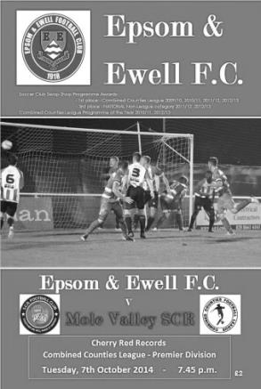
Following Tuesday's tight match against Mole Valley SCR, Sam Robinson and Taylor Smith came back into the starting eleven at the expense of Matt Ferdinando and Matt Robinson who both started on the bench. Smith was first to show when he flicked on a decent ball in, but the visiting keeper Josh Richardson was equal to the task. He needed to be at his best today as he was fairly busy. Robinson guided a header just wide of the far post before Kyle Hough controlled a Matt Tanton cross from the left with his chest and arm before shooting. The keeper blocked his effort well, not realising that the referee had already awarded the free kick for handball.

Dale Marvell was next to try his luck when cutting back and shooting just wide from the edge of the area but against the run of play in the 23rd minute the visitors took the lead with a nice move down the left when they had a man over. He was Julius Mngadi and his overlapping run finished with a low cross that was turned in at the far post by Tommy Mooney. It was a well-worked goal and as was the case on Tuesday, the one real piece of quality resulted in the only goal of the game.

Of course we weren't to know that at the time and it really shouldn't have been the case as within 90 seconds, Smith took advantage of a defensive slice to get in front of his man who then brought him down in the box while in the act of shooting. The kick was delayed for quite a while, first by a booking for Fearn, then by the keeper holding on to the ball, and finally by the referee who seemed to be waiting for some sort of signal. Whether or not this had an effect, only Hough will

know as his penalty was saved and the loose ball blasted wide by Smith, who probably should have done better even though the chance fell to his left foot.

Moments later Richardson was in action again as a great Dale Marvell pass was latched onto by Hough and he rounded the keeper only to see his effort blocked away by a defender. Tanton then had a shot deflected for a corner before James Taylor and then Smith headed over from Robinson corners. After 40 minutes Marvell ran onto a slide rule pass from Robinson and in attempting to block his cross, a defender stuck out a leg and deflected the ball over his own keeper but was fortunate to see the ball resting on the top of the net. Marvell then ran on to a great deep cross from the left with a stinging volley but it too was just wide of the far post.

It was beginning to feel a bit like the recent Frimley Green game where we had a hatful of chances but weren't taking them, except this time we were a goal behind. The second half provided little to cheer the home support as we set the tone by misplacing a number of passes and failed to create much for a while. Michael Eacott had to make his first save of the game after 52 minutes when he parried a powerful free kick but it was very rarely that they actually caused us real trouble.

After 65 minutes a rushed clearance by keeper Richardson went straight to Smith thirty yards out, but he chose to take a touch first and although his shot beat the retreating keeper, a defender had time to get there to clear the danger. As we approached the end of the game substitute Matt Robinson headed a good Tanton cross at goal from eight yards out but Richardson again made the stop.

Worse was to come on the ninety minute mark when frustration yet again got the better of Sam Robinson and his over the top challenge rightly earned a straight red card, his third in under forty games for us and his second of the season. Strangely, and despite only having ten men by that stage we nearly pulled an equaliser out of the hat when Matt Farrell climbed highest to head across goal; the ball bouncing back off the far post and away which summed up our day.

The defeat was frustrating, but could be explained away by saying that it was just one of those days in front of goal. However, the four game suspension for Robinson was more concerning to us long term as he will now miss the big F.A. Vase trip to Lingfield and the key League matches that follow it.

Team: Michael Eacott, James Taylor, Luke Gaffney, George Murphy ©, Dan Dean,
Matt Tanton, Matt Farrell, Sam Robinson, Taylor Smith, Kyle Hough, Dale Marvell

Subs: Matt Ferdinando for Marvell (68), Matt Robinson for Smith (78)

First Eleven Appearances - (max 16 inc Bedfont Sports)
Name | Debut | 2014/15 |  |  |  | Career Totals
 |  | App | Sub | Total | Goals | App | Sub | Total | Goals
BROWN Oshane* | 30/08/2014 | 2 | 0 | 2 | 0 | 2 | 0 | 2 | 0
CURRIE Sam | 04/08/2012 | 2 | 0 | 2 | 0 | 96 | 5 | 101 | 2
DEAN Dan | 02/08/2014 | 14 | 0 | 14 | 0 | 14 | 0 | 14 | 0
DEWAR Ali | 29/10/2011 | 4 | 1 | 5 | 3 | 54 | 30 | 84 | 10
DOUGLIN Karl* | 03/08/2013 | 1 | 0 | 1 | 1 | 41 | 3 | 44 | 14
DOWNS Carl* | 17/09/2011 | 4 | 1 | 5 | 0 | 94 | 13 | 107 | 2
EACOTT Michael | 02/08/2014 | 14 | 0 | 14 | 0 | 14 | 0 | 14 | 0
FARRELL Matt | 02/08/2014 | 15 | 1 | 16 | 2 | 15 | 1 | 16 | 2
FERDINANDO Matt | 20/09/2014 | 3 | 3 | 6 | 0 | 3 | 3 | 6 | 0
GAFFNEY Luke | 16/08/2014 | 7 | 1 | 8 | 0 | 7 | 1 | 8 | 0
HARPER Tommy | 15/04/2014 | 1 | 0 | 1 | 0 | 2 | 1 | 3 | 0
HAYWARD Ben | 07/03/2007 | 5 | 0 | 5 | 0 | 241 | 28 | 269 | 18
HOADLEY Harry | 15/04/2014 | 6 | 1 | 7 | 0 | 7 | 1 | 8 | 0
HOUGH Kyle | 14/08/2007 | 14 | 0 | 14 | 4 | 268 | 12 | 280 | 141
JARMAN Mark | 08/08/2009 | 2 | 4 | 6 | 0 | 133 | 50 | 183 | 76
MARVELL Dale | 15/01/2000 | 10 | 3 | 13 | 5 | 260 | 43 | 303 | 85
MURPHY George | 28/03/2013 | 11 | 1 | 12 | 1 | 52 | 5 | 57 | 3
MUTIMA Lionel | 05/08/2014 | 4 | 2 | 6 | 0 | 4 | 2 | 6 | 0
NELMES Elliott* | 05/08/2014 | 2 | 0 | 2 | 0 | 2 | 0 | 2 | 0
PANAYI Anthony | 14/11/2010 | 8 | 1 | 9 | 0 | 135 | 15 | 150 | 4
ROBINSON Matt | 01/12/2012 | 1 | 1 | 2 | 0 | 2 | 4 | 6 | 1
ROBINSON Sam | 22/10/2011 | 10 | 1 | 11 | 4 | 34 | 4 | 38 | 9
SHAW Ollie | 20/09/2014 | 0 | 4 | 4 | 0 | 0 | 4 | 4 | 0
SMITH Taylor | 02/08/2014 | 12 | 0 | 12 | 5 | 12 | 0 | 12 | 5
TANTON Matt | 02/08/2014 | 10 | 2 | 12 | 1 | 10 | 2 | 12 | 1
TAYLOR James | 26/08/2013 | 11 | 1 | 12 | 1 | 28 | 7 | 35 | 2
VAN GELDER Julian* | 12/09/2006 | 0 | 1 | 1 | 0 | 0 | 2 | 2 | 0
WHITE Sean | 02/08/2014 | 3 | 6 | 9 | 2 | 3 | 6 | 9 | 2
* Player has left the club

EL Records Premier Challenge Cup
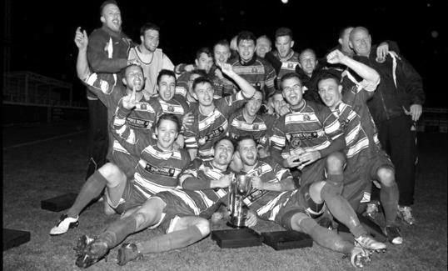
First Round
Raynes Park Vale | 0-5+ | Spelthorne Sports
Bedfont Sports | 3-1 | Staines Lammas
Chertsey Town | 4-2 | Hartley Wintney
Frimley Green | 2-1+ | AFC Croydon Athletic
Sandhurst Town | 1-5 | Horley Town
Second Round
Alton Town | 14/10 | Farnham Town
Ashford Town (Mx) | 5-0 | CB Hounslow United
Badshot Lea | 14/10 | Dorking
Bedfont Sports | 14/10 | Cove
Camberley Town | 14/10 | Molesey
Chertsey Town | 14/10 | Windsor
Cobham | 14/10 | Horley Town
Colliers Wood United | 3-0 | Bedfont & Feltham
Epsom & Ewell | 14/10 | Knaphill
Epsom Athletic | 15/10 | Banstead Athletic
Eversley & California | 21/10 | Ash United
Frimley Green | 14/10 | Spelthorne Sports
Hanworth Villa | 14/10 | Guildford City
Sheerwater | 1-6 | Mole Valley SCR
Westfield | 14/10 | Farleigh Rovers
Worcester Park | 29/11 | Chessington & Hook United

Club Records - 14th October
Date | Day | Competition |  | Opponents |  | Scorers
14/10/33 | Sat | F.A. Cup 2q | A | Tooting & Mitcham United | 1-0 | J.Jones
14/10/50 | Sat | Surrey Senior Cup 2q | H | McLaren Sports | 3-1 | S.Faggetter (2), T.Wright
14/10/61 | Sat | Amateur Cup 1q | H | Worcester Park | 2-0 | J.Leedham, B.Robinson
14/10/67 | Sat | Surrey Senior Cup 1q | H | Dorking | 2-0 | T.Stafford, R.Battams
14/10/72 | Sat | Surrey Senior Cup Preliminary Round | A | Whyteleafe | 0-1+
14/10/78 | Sat | F.A. Trophy 1q | A | Croydon | 0-5
14/10/86 | Tue | Isthmian League 1 | A | Uxbridge | 2-2 | R.Purvis, D.Jones
14/10/89 | Sat | Isthmian League 2s | A | Flackwell Heath | 1-1 | B.Horn
14/10/00 | Sat | Isthmian League 3 | H | Ashford Town (Mx) | 1-2 | T.Smith
14/10/03 | Tue | Isthmian League 1s | A | Worthing | 1-1 | J.Rogers
14/10/06 | Sat | Combined Counties Premier Division | H | Guildford City | 2-0 | J.Watson, A.Pero
14/10/08 | Tue | Surrey Senior Cup 1 | H | Horley Town | 1-0 | D.Marvell
Historical Decades
90 years ago – Epsom Town
11/10/24 | Sat | Friendly | A | Metrogas | 6-0 | R.Marlow (3), R.Sperring, J.Parr, F.Kent
80 years ago – Epsom F.C.
13/10/34 | Sat | F.A. Cup 2q | H | Guildford City | 2-4 | E.Hannam, T.Dunne
70 years ago – War time Epsom Town
14/10/44 | Sat | South Eastern Combination | A | Erith & Belvedere | 0-2
60 years ago – Epsom F.C.
16/10/54 | Sat | Amateur Cup 2q | H | Uxbridge | 0-4
50 years ago – Epsom & Ewell
17/10/64 | Sat | Athenian League Cup 1 | H | Tilbury | 0-3
40 years ago – Epsom & Ewell
12/10/74 | Sat | Surrey Senior League Charity Cup 1 | H | Westfield | 6-2 | J.Eales (3), T.Tuite, T.Lee (pen), D.Worby
30 years ago – Epsom & Ewell
13/10/84 | Sat | F.A. Cup 3q | H | Bognor Regis Town | 4-5 | S.Hill (2), T.Tuite (2)
20 years ago – Epsom & Ewell
15/10/94 | Sat | Isthmian League 3 | A | Tring Town | 2-3 | B.Stone (2)
10 years ago – Epsom & Ewell
16/10/04 | Sat | Isthmian League 2 | H | Chalfont St Peter | 3-0 | M.Owen (2), R.Shoefield

History Corner – 14th October
81 years ago today we travelled to Sandy Lane, home of the newly merged Tooting & Mitcham United. Tooting Town and Mitcham Wanderers, both regular London League rivals for Epsom had put any differences aside and merged into the club we know now in 1932. There was only room for so many players and we picked up Dick Wilson the durable defender. He played well as did the rest of the team in a 1-0 win on our way to the First Round Proper.

80 years ago this week there were 3,300 present to witness another great win in the F.A. Cup. Unfortunately, Guildford City hadn’t read the script and the professional Southern League side came away from West Street with a 4-2 win. There would be no trip to the First round for us that year, although Guildford would get there.

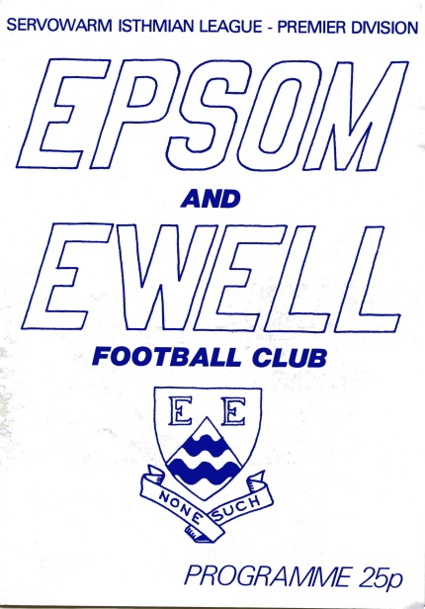
30 years ago this week the club faced a pivotal match up in the F.A. Cup against Bognor Regis Town. We both played at the same level, following our promotion that summer, and would actually complete a “double” over them this season, but we were always behind in this match, and although we got back level twice, the Rocks pulled away to lead 5-2 before two late goals made for a thrilling finalé. (see programme right)

Bognor received an easy home tie against Frome Town in the next round before pulling out the plum draw of Swansea City at the Vetch Field, who they promptly beat after a replay, eventually losing out to Reading in the second round. This was extremely frustrating, knowing how close we had come to getting there ourselves.

28 years ago today we were struggling towards the foot of the Isthmian League Division One. This day we were due to visit Uxbridge, but we hit traffic troubles on the way and only started the match with nine players but somehow managed to pull a 2-2 draw out of the game with goals from Ray Purvis and young striker David Jones.

11 years ago today and here is a similar story. In 2003/04 we were struggling at the foot of the Isthmian League Division One South and travelled to Worthing more in blind faith than expectation. It got worse as we heard that we had been delayed in traffic, so Matt Sargeant made his debut in goal in relief of Dave Hyatt but despite trailing, a Joel Rogers goal secured us an unlikely point from a 1-1 draw.

8 years ago today we won our first match in the Combined Counties League. After transferring there we had struggled badly in our opening fixtures and had already lost Paul Pritchard as Manager. Caretaker Peter Augustine was in charge as we waited for the next full time appointment, but a 2-0 win over Guildford at least ensured we wouldn’t be bottom when Lyndon Buckwell took over in November.

Knaphill F.C. – History
History of the Knappers….The Story so far…….

Knaphill Football Club began its life in 1924 at Waterer's Park, which was left to Woking Urban District Council in 1924 by Mr Anthony Waterer of Knaphill Nursery. The Recreation Ground was originally part of the nursery called "Blue Gates Field" and the park was laid out by Woking Council between 1924 and 1928. Very little history is known or available about the Club between 1924 and 1980.

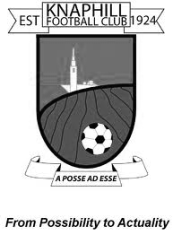
In 1980, Knaphill were represented in the Old Woking and District League (now Guildford and Woking Alliance League) in Division 3 under Manager Dave Holloway. Dave took them from Division 3 through promotion to the Surrey Intermediate League. He then left Knaphill to take over Conference side Woking's reserve and youth teams. The late Andy Westcott took over the Manager's position at Knaphill in 1984. He successfully took the Club from Division 3 to the Premier Division 1.

Mick Garbutt became the Manager of Knaphill in 1990, but in 1994 departed to join up with Colin Lippiatt and Geoff Chapple at Woking. After this time the club went into decline and was struggling for players for both the First and Reserve Teams. The decision was taken by then Senior Secretary, Sean Carrigy, to approach local team Heathlands, who were playing in the Guildford and Woking Alliance League. Heathlands found themselves struggling for facilities but not players; which gave the two teams the opportunity to amalgamate.

In 1996 David Freeman took over from First Team Manager Greg Anderson, who was in charge for just one season 1995/96. Season 2002/03 saw 2 new men at the helm with Mick Garbutt in charge of the 1st Team and David Freeman as 1st team coach. At the start of the 2003/2004 season the club formed a third team named Knaphill 'A' to play in the Guildford & Woking Alliance League due to volume of players at the club.

The 2004/2005 season brought about further changes at team management level seeing David Freeman retiring from playing due to injuries and being appointed as 1st Team Manager with Mick Garbutt stepping down to Assistant Manager. Carl Barker relinquished his ‘A’team role to become Chairman. The club also moved into their new ground at Redding Way and the re-development of the Waterers Park ground finished in April 2005, gave Knaphill Football Club some of the best facilities in the Surrey area. Season 2005/2006 was destined to be a big season for the club with the club established at its new ground at Redding Way and the’ A’ team reverting back to Waterers Park having had the facilities rebuilt.

First Team Manager David Freeman continued in charge for the 2005/2006 campaign and appointed former professional with Bristol City, Bob Pritchard, who had also managed at senior level with Chertsey Town, amongst others, as 1st Team Coach. Kevin Fletcher was appointed Reserve Team Manager having impressed by running the A Team the previous season. The 2005/2006 season did prove successful as we won the Division One title on the last day of the season against nearest rivals Virginia Water and gained promotion to the Premier Division.

2006/2007 continued with David Freeman in charge of the first Team and Paul Bailey re-appointed as Reserve Team Manager. The first Team claimed back to back titles by winning the Premier Division Championship which resulted in us achieving promotion to the Combined Counties Football League, the most successful period in the clubs history up to then. Bob Pritchard took over from David Freeman as Manager who then became Bob’s assistant during September 2007.

The 2007/08 season was the busiest the club has ever endured. Over 45 matches were played at Redding Way and the pitch was still the best in the league at the end of the season. Bob Pritchard and David Freeman took the team to a very commendable 7th place.

The 2008/09 season started with a most welcome new face, the former Bisley and Farnborough Assistant Manager, Ian Savage. Ian joined us as player/coach and with his experience and knowledge this club had the right to feel proud that he chose to join Knaphill after receiving

many other offers from teams at higher levels.

With a reduction in League games in Division One to 34 from 38, we kept a high profile in the League staying in the top half of the table all season, eventually finishing in fifth place. They could have become champions had they won their last game of the season when, in a tightly bunched set of teams in the top six. We needed to win at Farleigh to pip Staines Lammas to the title. Disappointingly we lost 3-2, so near yet so far. In the close season Terry Chapman became the new Chairman, replacing Nick Croshaw who stood down after two seasons.

The 2009/10 season saw the team finish third in Division One, their best placing in the three seasons in the Combined Counties League. Third would normally have gained the Club promotion, but due to the proposed floodlights installation being delayed, Knaphill had to make another challenge for promotion in 2010/11. The team won 26 out of their 40 league games, losing 10 with 4 drawn, scoring 98 goals and finished with 82 points.

Season 2010/11 was one of two halves for the first team, having suffered a poor string of results in the first four months of the season the turn of the year went onto see an unbeaten run of 12 matches. But the run was not enough to see us get close enough to a promotion place, and after reaching fifth in the table in the final run in, slipped to finish ninth in Division One. The newly formed Knaphill Youth U18s, played their first season in the Allied Counties League, and reached the final of the Grant McLellan Youth Cup, but lost 2-0 to Bedfont Sports. The installation of the Floodlights at Redding Way came to fruition in March 2011, together with a 50 seater Stand.

The 2011/12 season saw Knaphill entering the F.A. Vase for the first time, but unfortunately fell at the first hurdle, knocked out by Horley Town. In the League, Knaphill produced some poor results there was a change of management during the season, and some players left the Club. When new team boss Phil Ellery, took over by the beginning of November, it was to become a case of rebuilding the side, and get them as high in the table as possible. After a brief flourish of encouraging results, the team finished 12th in Division One. The Ladies team and Girls U18s played under the Knaphill banner for the first season, the latter becoming champions in their League. Our Youth team reached the Grant McLellan Cup final for the second year running, but were beaten finalists. Chairman Terry Chapman stood down as Chairman, and David Freeman, 16 years at Knaphill, took over the role in the first half of the season.

The arrival of season 2012/13, and one of which the Club would be hoping to put in a strong challenge for promotion in the Combined Counties League, and fare better in Cup competitions. However, it turned out to be a disappointing season. A Management change within the first quarter of the season saw Phil Ellery leave the Club, and Kevin Bailey and Phil Ruggles were installed as joint first team managers,. But whilst losing some players as the season progressed, there were several new signings throughout the remainder of the 2012/13 season, which finished with the team in 12th place in Division One for the second successive season, the lowest the team have been in six years in the CCL.

So season 2013/14 emerged with Phil Ruggles as 1st team Manager, and Steve Pearman as his Assistant, and players wise, many new faces in the squad, with everyone eager to bring some success in League and Cup competitions. It was our seventh season in the Combined Counties League, and it proved to be a season that showed more progression for the Club. Promotion to the Premier Division! There was also a nice ‘mini run’ in the F.A. Vase with wins over Badshot Lea, Tadley Calleva and Dorking, before going out of the competition at home to East Preston. But with the team never out of the top five all season, the League success saw Knaphill go into the last game of the season in second place, behind the eventual champions Spelthorne Sports, and ahead of third placed Eversley & California. Knaphill finished with a well-earned point in the 1-1 draw at Spelthorne, but following Eversley’s unbelievable 11-2 win over Sandhurst, we dropped into third spot on goal difference, but still gained promotion to the Premier, and it was Onwards and Upwards!

The 2014/15 season brings forth a big League programme of 40 games, in comparison with just 30 matches in Division One last season. Knaphill enter the F.A. Cup for the first time, and continue taking part in the F.A. Vase, and with other Cup competitions, it’s going to be a busy 2014/15 season in progress, in this the Club’s 90th Year.

Centre page for results

Centre page for results

Club Directory
ASHFORD TOWN (Mx) Telephone: 01784-245908 - Ground: The Robert Parker Stadium, Short Lane, Stanwell. TW19 7BH - Colours: Tangerine & White Stripes/Black/Tangerine

BADSHOT LEA Telephone: 01252-320385 - Ground: Ash United FC, Shawfield Stadium, Youngs Drive, Shawfields Road, Ash, Hampshire. GU12 6RE - Colours: Claret/White/Claret

BEDFONT SPORTS Telephone: 0208-831-9067 - Ground: Bedfont Sports Club, Hatton Road, Bedfont, Middx TW14 8JA - Colours: Red & Black Hoops/Black/Red & Black Hoops

CAMBERLEY TOWN Telephone: 01276-65392 - Ground: Krooner Park, Wilton Road, Camberley, Surrey. GU15 2QW - Colours: Red & White Stripes/Blue/Red

CHERTSEY TOWN Telephone: 01932-561774 - Ground: Alwyns Lane, Chertsey, Surrey. KT16 9DW - Colours: Royal Blue & White Stripes/Royal Blue/Royal Blue

COLLIERS WOOD UNITED Telephone: 0208-942 8062 - Ground: Wibbandune Sports Ground, Lincoln Green, Opposite 199-213, Robin Hood Way, Wimbledon. SW20 0AA - Colours: Blue & Black Stripes/Black/Black

COVE Telephone: 01252-543615 - Ground: Oak Farm Fields, 7 Squirrel Lane, Cove, Farnborough, Hampshire. GU14 8PB - Colours: Yellow/Black/Yellow

EPSOM & EWELL Telephone: 01737-553250 - Ground: Chipstead FC, High Road, Chipstead, Surrey. CR5 3SF - Colours: Royal Blue & White Hoops/Royal Blue/Royal Blue & White Hoops

FARNHAM TOWN Telephone: 01252-715305 Ground: Memorial Ground, Babbs Mead, West Street, Farnham, Surrey. GU9 7DY Colours: - Claret & Sky Blue /White/ Claret & Sky Blue

FRIMLEY GREEN Telephone: 01252-835089 - Ground: Frimley Green Recreation Ground, Frimley Green Road, Frimley Green, Camberley, Surrey. GU16 6JY - Colours: Blue & White/Blue/Blue

GUILDFORD CITY Telephone: 01483-443322 - Ground: The Spectrum, Parkway, Guildford, Surrey. GU1 1UP - Colours: Red & White Stripes/Black/Black

HANWORTH VILLA Telephone: 0208-831-9391 - Ground: Rectory Meadows, Park Road, off Hounslow Road, Hanworth, Middlesex. TW13 6PN - Colours: Red & White Stripes/Black/Black

HARTLEY WINTNEY Telephone: 01252-843586 - Ground: Memorial Playing Fields, Green Lane, Hartley Wintney, Hants RG27 8DL - Colours: Orange & Black/ Orange /Orange

HORLEY TOWN Telephone: 01293-822000 - Ground: The New Defence, Anderson Way, Court Lodge Road, Horley, Surrey. RH6 8SP - Colours: Claret & Sky Blue/Claret/Claret

KNAPHILL Telephone: 01483-475150 - Ground: Brookwood Country Park, Redding Way, Lower Guildford Road, Knaphill, Surrey. GU21 2AY - Colours: Red/Black/Red

MOLE VALLEY SCR Telephone: 01932-866386 - Ground: Cobham FC, Leg O’Mutton Field, Anvil Lane, Downside Bridge Road, Cobham, Surrey KT11 1AA - Colours: Yellow/Black/Black

MOLESEY Telephone: 0208-979-4283 - Ground: 412 Walton Road, West Molesey, Surrey KT8 2JG - Colours: White/Black/Black

RAYNES PARK VALE Telephone: 020-8540-8843 - Ground: Prince Georges Playing Field, Grand Drive, Raynes Park, London. SW20 9NB - Colours: Blue/Blue/Red

SPELTHORNE SPORTS Telephone: 01932-961055 - Ground: Spelthorne Sports Club, 296 Staines Road, Ashford Common, Ashford, Middx. TW15 1RY - Colours: Light & Dark Blue/Dark Blue/Light Blue

WESTFIELD Telephone: 01483-771106 - Ground: Woking Park, Kingfield Road, Woking, Surrey. GU22 9BA - Colours: Yellow/Black/Black

WINDSOR Telephone: 01753-860656 - Ground: Stag Meadow, St Leonards Road, Windsor, Berks SL4 3DR - Colours: Red/Red/Red

Match and Ball Sponsorships – 2014/15
Opponent | Date | Match Sponsor | Ball Sponsor
Raynes Park Vale | 05/08/14 | Club President - Stella Lamont
Horley Town | 25/08/14 | Epsom & Ewell F.C. Management Committee
Croydon (FAC) | 30/08/14 | Media Officer - Richard Lambert
Frimley Green | 13/09/14 | Dave Gaffney and friends
Guildford City | 30/09/14 | The Jarman family
Mole Valley SCR | 07/10/14 | Mark and Carmel Murphy
Bedfont Sports | 11/10/14 | Epsom & Ewell F.C. Colts
Knaphill (LC) | 14/10/14 | Geoff and Steve Dyke
Ashford Town (Mx) | 18/10/14 | The Building Shop, Bookham
Chertsey Town | 28/10/14
Molesey | 22/11/14 | Provisional and dependent on any Vase progress
Camberley Town (SSC) | 02/12/14 | Provisional date
Hanworth Villa | 06/12/14
Windsor | 03/01/15
Farnham Town | 17/01/15
Westfield | 31/01/15
Camberley Town | 07/02/15
Hartley Wintney | 21/02/15
Cove | 07/03/15
Badshot Lea | 21/03/15
Colliers Wood United | 04/04/15
Knaphill | 18/04/15
Spelthorne Sports | tba
For League, League Cup and Surrey Senior Cup Matches:

Match sponsorship - £40.00 Match ball sponsorship - £25.00.
Combined Offer of Match and Match Ball sponsorship for £55.00.

For F.A. Cup and F.A. Vase matches:

Match sponsorship - £50.00 Match ball sponsorship - £30.00.
Combined Offer of Match and Match Ball sponsorship for £65.00.
----------------------------------------------------------------------------------------------------------------------------
Sponsorship includes

Admission, programmes, advertising (if required) and hospitality.

If you are interested, just speak to a Committee Member, you know where we are!
Alternatively, drop me an email at: richard.c.lambert@gmail.com

Player Sponsorship
Here is the latest list showing all of the players and Management available for sponsorship. Sponsorship costs £40 so if you want to help the club, the player and get your name in the programme for the season, just let us know.

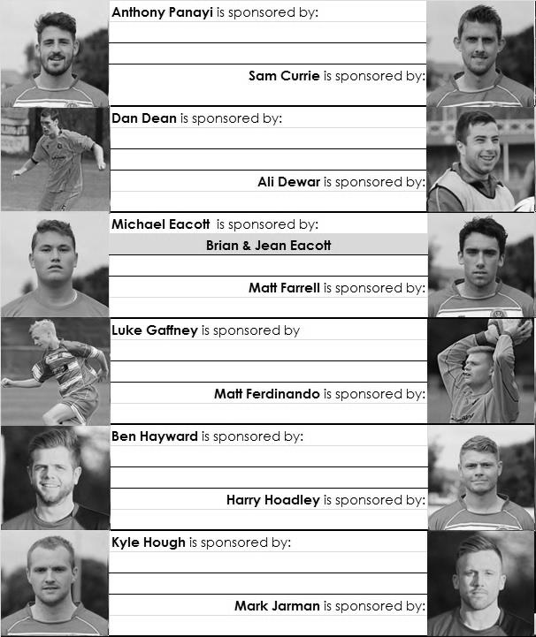

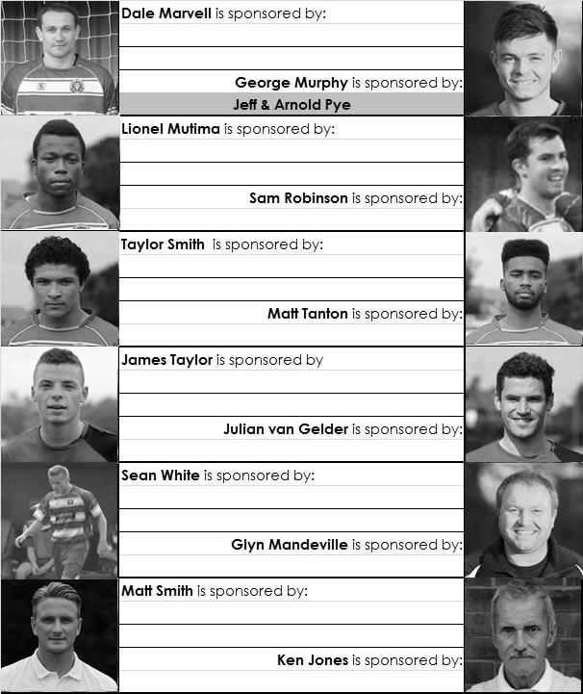

We are not fussy; we’ll take cash or a cheque! Any donation will help the club and is much appreciated.

Every Opponent A-Z
Over the years we have played many, many different opponents. Exactly how many is a difficult question, as it all depends on your definition. Are Camberley & Yorktown different to Camberley Town, or are Epsom Town different to Epsom F.C. or Epsom & Ewell F.C.?

In my analysis I have classed them as the same team, and will work through them all from A to Z. Some we have played many times, whilst others we have met maybe just once or twice. Enjoy!

Lion Sports: Played 10 - W4 D3 L3 - F18 A11 - PPG - 1.50 - Average

Lion Sports were a works team that were regulars in the Surrey Senior League during the sixties and seventies. They played at Lion Park which was in Church Road, Bisley and we first met them on 4th November 1967 for an Amateur Cup tie, drawing 2-2 but losing the replay on our first visit by the only goal a week later.

We had revenge in the same competition two seasons later when we drew 0-0 over there, but this time a Tony Seymour goal in the replay at West Street was the difference between the teams, and our final meeting in the Amateur Cup resulted in a conclusive defeat as we were hammered 4-0 there on 26th September 1970. We were truly awful that season!

Our next meetings were as members of the Surrey Senior League following our demotion in 1973. We played them towards the end of the season, travelling there on a Tuesday evening but again losing 2-1 and Tommy Tuite secured a 1-1 draw in the return match on 4th May.

The following season 1974/75 was of course very different and a Tuite hat trick helped us on our way to a 5-0 win to open the next season; one in which we would become Champions. We repeated the score at West Street in February 1975 and our final meeting came in November 1976 when we beat them 3-1 at Church Road (pictured below in 2012) in the Surrey Senior Cup.
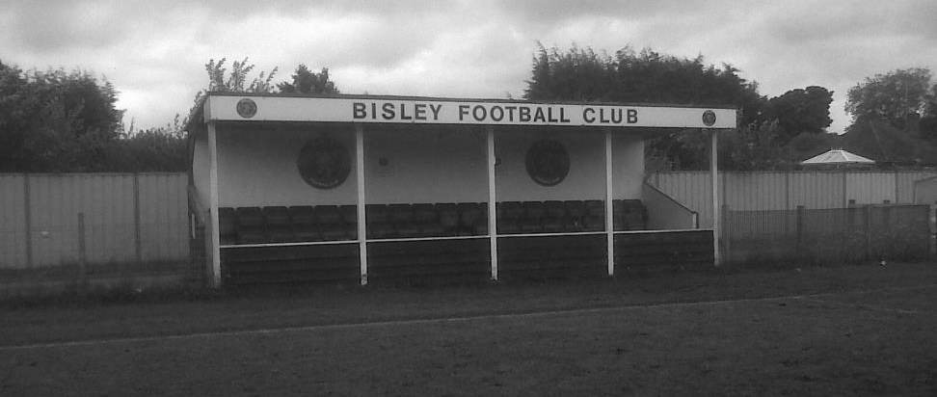

Their final season in the Surrey Senior League, by now renamed the Combined Counties League was in 1980/81 when they finished 8th out of 19. I believe that the works facility closed at that time, leading to the demise of the team but not the ground. In fact we played there in July 2012 when meeting Sheerwater in a pre-season friendly. In the meantime the ground had recently been used by Bisley F.C. in the Hellenic League (requiring floodlights) and then Farnborough Reserves. The lights are now removed but the ground still shows memories from the past.

Lloyds Bank: Played 1 - W0 D0 L1 - F2 A4 - PPG - 0.00

We met Lloyds Bank just once, in the East Surrey Hospital Cup Final of 1927/28 which was held over until the 26th September as we were otherwise engaged in winning the London League title. After defeating Redhill in the Semi-Final there was to be a new name on the trophy and we put out a reasonably strong side but just weren’t good enough on the day, winning 4-2 at West Street. It must be remembered that works sides of all shapes and sizes were decent back then, and later in the season we would also be held to a draw by the Westminster Bank, now better known as Nat West, in the Surrey Senior Cup!

London University: Played 2 - W1 D1 L0 - F9 A2 - PPG - 2.00 - Very Good

We played against London University twice, once in December 1935 when we drew 2-2 at West Street and again in the Amateur Cup, playing at their ground in Motspur Park when we were held 0-0 at half time but ended up winning 7-0 in the end!

Long Buckby: Played 1 - W0 D0 L1 - F2 A3 - PPG - 0.00

A trip to Northamptonshire is very rare, and this tells you that this must have been an important match. In fact it was a very rare F.A. Vase Fourth Round tie, only our fourth ever. Obviously we only won one of these four matches, on our way to Wembley Stadium for the 1975 Final, but since then, Eastbourne United and Hailsham Town had blocked our path at West Street. We had waited twenty-one years for another go and following our win over Wellington in the previous round, we felt that we were perfectly capable of clearing this hurdle.

Everything started well as we won an admittedly soft penalty after 8 minutes and Kyle Hough struck the ball in as he usually does. However, a foul on Paul Borg was not given and he and the ball ended up in the net for an equaliser soon after. Unfortunately two goals either side of half time gave them a winning lead, although a wayward back pass that was going in before Robbie Burns got there first to poke the ball over the line and reduce the deficit to 3-2.

This led to a nervy finish but unfortunately we were unable to force a replay and Long Buckby travelled to Gresley in the last 16 instead of us. Pity!

Luton Amateurs: Played 1 - W1 D0 L0 - F8 A1 - PPG - 3.00 - Perfect

We met Luton Amateurs in a Christmas friendly at West Street on Boxing Day 1930 but it was a complete mismatch as the papers described the opposition as “very amateur”. Herbert Pattimore scored a hat trick as we won by eight goals to one this day.

F.A. Vase
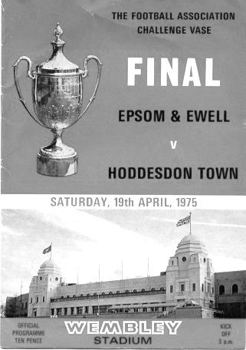
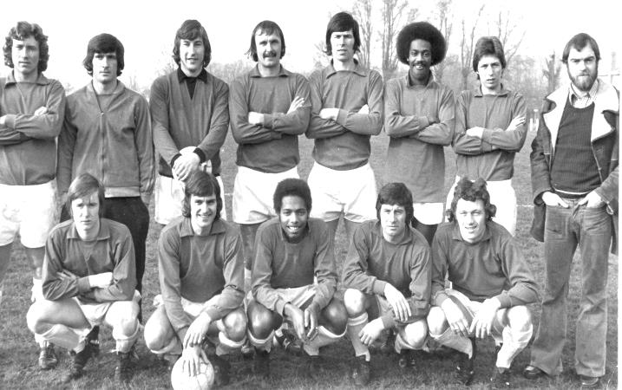
Second Qualifying Round – 4th October
Colliers Wood United | 2-1 | Shoreham
Cray Valley (PM) | 0-2 | Horley Town
Farnham Town | 2-1 | Milton United
Flackwell Heath | 5-0 | Frimley Green
Highworth Town | 2-1+ | Hartley Wintney
Spelthorne Sports | 2-1 | Risborough Rangers
Molesey | 1-2 | Greenwich Borough
Raynes Park Vale | 2-1 | Epsom Athletic
Rothwell Corinthians | 0-1 | Bedfont Sports
Windsor | 4-0 | Binfield
Woodley Town | 0-2 | Knaphill
First Round Proper – 1st November
Ashford Town (Mx) | V | Loxwood
Chertsey Town | V | Horley Town
Chessington & Hook United | V | Camberley Town
Colliers Wood United | V | Ringmer
Farnham Town | V | Abingdon United
Horsham YMCA | V | Bedfont Sports
Lingfield | V | Epsom & Ewell
Littlehampton Town | V | Guildford City
Lordswood | V | Knaphill
Pagham | V | Spelthorne Sports
Raynes Park Vale | V | Westfield
Windsor | V | Highworth Town
Hanworth Villa are exempted to the Second Round

Surrey Senior Cup
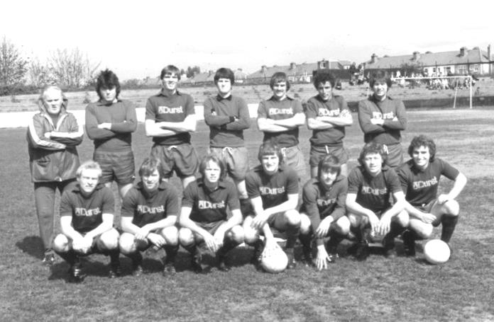
First Round
Carshalton Athletic | 21/10 | Egham Town
Croydon | V | Colliers Wood United
Merstham | 21/10 | Whyteleafe
Raynes Park Vale | 21/10 | Chertsey Town
South Park | 21/10 | Guildford City
Second Round
Lingfield | V | Westfield
Redhill | V | Raynes Park Vale /  Chertsey Town
AFC Wimbledon | V | Chipstead
Godalming Town | 11/11 | Mole Valley SCR
Knaphill | V | Croydon /  Colliers Wood United
Metropolitan Police | V | Walton & Hersham
Epsom & Ewell | V | Camberley Town
Leatherhead | 26/11 | Farnham Town
Merstham / Whyteleafe | V | Beckenham Town
Molesey | V | Carshalton Athletic /  Egham Town
South Park / Guildford City | V | Sutton United
Walton Casuals | V | Corinthian Casuals
Badshot Lea | V | Kingstonian
Dorking Wanderers | V | Frimley Green
Tooting & Mitcham United | V | Horley Town
Woking | V | Ashford Town (Mx)

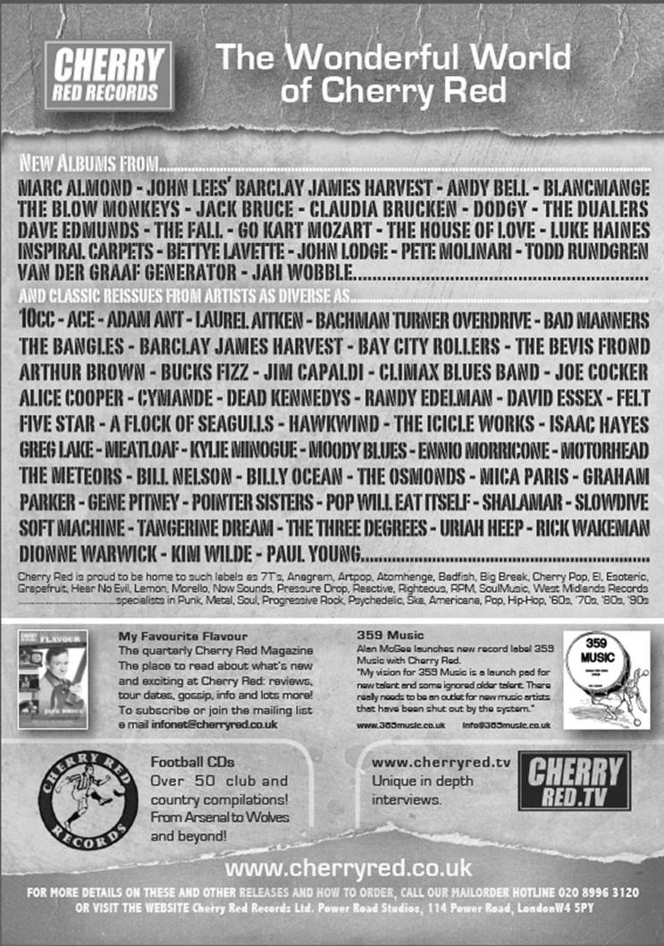

Our New Website
Have you seen our website?

For those who are unaware, our website, now over a year old, contains everything you could possibly want to know about the club and an enormous amount you may not have been aware of!

Our previous site will still exist, as a photo archive only, housing the enormous wealth of pictures provided by Gemma Jarman, our Club photographer. In addition, there are over a thousand historical images of teams, players, action shots and programme covers.

As you can tell from the screenshot of our front page, there is a substantial amount of information all available at the touch of a button, which is also very useful if you own one of those new touchscreen personal computers that are becoming more and more popular these days.

If you are a supporter, please pass the address on to anyone you know that has ever expressed an interest in the club, especially those who don’t visit any more. You never know, some of them might be inspired to come along too, and bring their friends etc.

http://www.eefconline.co.uk/

Combined Counties League Cup – Second Round
Tuesday, 14th October 2014 - Kick-off 7.30 p.m.
Epsom and Ewell  (Royal Blue & White hoops) | V |  | Knaphill  (Red and Black)
 | NUMBERS
Michael Eacott |  |  | Richard Shelley
James Taylor |  |  | Jordain Pearce
Luke Gaffney |  |  | Timmy Taylor
© George Murphy |  |  | Matt Morris
Dan Dean |  |  | Jamie Doble
Matt Tanton |  |  | Darrell Harris
Sam Robinson |  |  | Josh Watkins
Matt Farrell |  |  | Connor Close
Taylor Smith |  |  | Jahmal Ramsay
Kyle Hough |  |  | Jimmy Notman
Dale Marvell |  |  | Ricky Hogsden
Mark Jarman |  |  | David Johnston
Lionel Mutima |  |  | Tom Postance
Matt Ferdinando |  |  | Jamie Daltrey
Ollie Shaw |  |  | Charlie Oakley
Anthony Panayi |  |  | Nahum Green
Ben Hayward |  |  | Chris Paterson
Ali Dewar |  |  | Pete Ruggles
Matt Robinson |  |  | Josh Coke
Harry Hoadley |  |  | Sam Taylor
 |  |  | Scott Costello
 |  |  | Joel Sanderson
Glyn Mandeville | MANAGER |  | Phil Ruggles
Matt Smith | ASSISTANTS |  | Steve Pearman
Steve Eacott | OTHER COACHES |  | Keith Hills / Roland Baker
REFEREE: G.Worrell (Thornton Heath)
ASSISTANTS: J.Lidbetter (Surbiton), L.Gordon (Wallington)
Today’s Match and Match Ball are sponsored by Geoff and Steve Dyke. Both have clocked up many years of service as supporters while Steve is also Vice-Chairman and Treasurer.

OUR NEXT VISITORS TO HIGH ROAD
Ashford Town (Middx)
Saturday 18th October 2014 - Kick-off 3.00 p.m.
Combined Counties League – Premier Division

